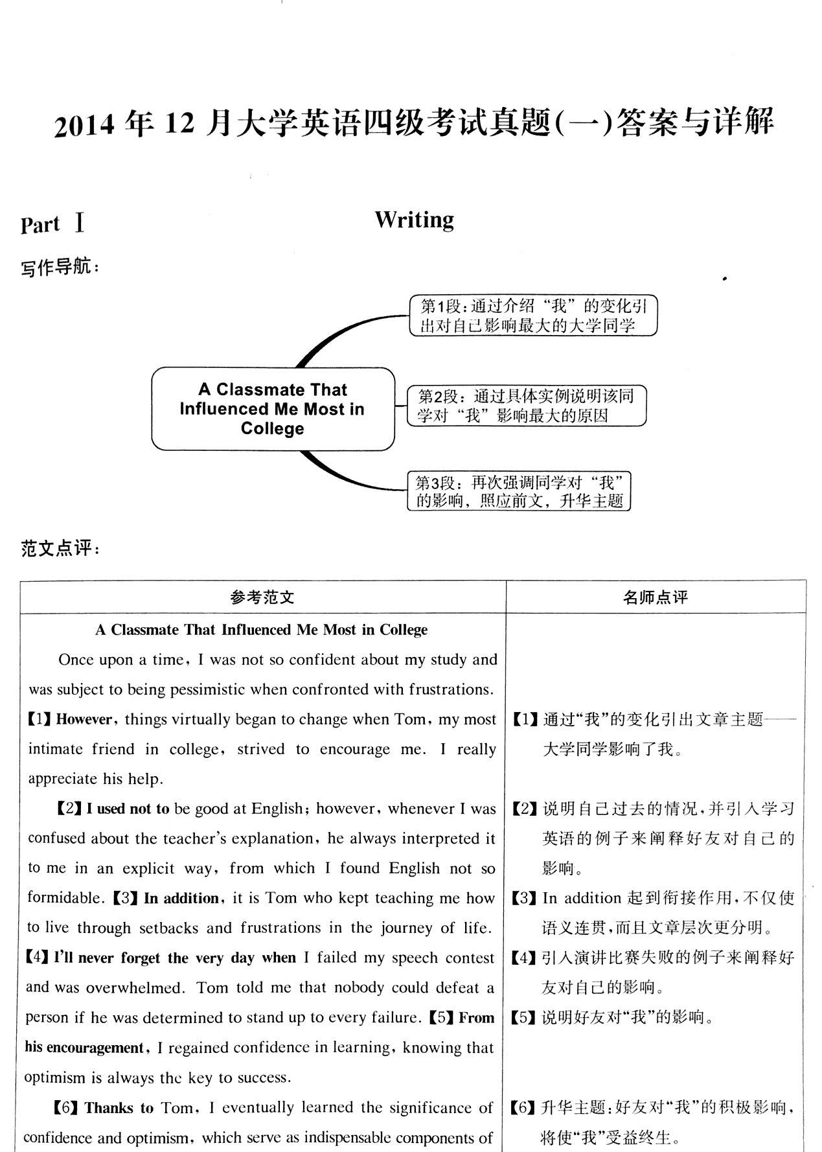

26-35 HNKFJELMBG

36-45 FDJCIMBHEG

46-50 ACBDB

51-55 DDABC

